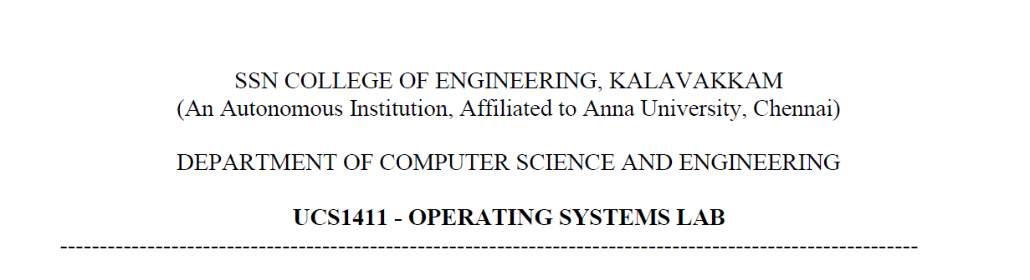

**LAB EXERCISE 6**

Name: Jayannthan P T

Dept: CSE ‘A’

Roll No.: 205001049



1. To Implement Knapsack Algorithm
   1. **Code:**

#include <bits/stdc++.h>

using **namespace** std;

**int** KNAPSACK_GREEDY(**int** W, **int** v[], **int** w[], **int** n)

{

    if (n == 0 or W == 0)

    {

        return 0;

    }

    if (w[n - 1] > W)

    {

        return KNAPSACK_GREEDY(W, v, w, n - 1);

    }

    else

    {

        return max(KNAPSACK_GREEDY(W, v, w, n - 1), v[n - 1] + KNAPSACK_GREEDY(W - w[n - 1], v, w, n - 1));

    }

}

**int** KNAPSACK_DP(**int** W, **int** v[], **int** w[], **int** n)

{

    vector<vector<**int**>> F(n + 1, vector<**int**>(W + 1));

    for (**int** i = 0; i <= n; i++)

    {

        for (**int** j = 0; j <= W; j++)

        {

            if (i == 0 or j == 0)

            {

                F[i][j] = 0;

            }

            else if (w[i - 1] <= j)

            {

                F[i][j] = max(F[i - 1][j], v[i - 1] + F[i - 1][j - w[i - 1]]);

            }

            else

            {

                F[i][j] = F[i - 1][j];

            }

        }

    }

    return F[n][W];

}

**int** main()

{

**int** n;

    cout << "\nEnter no. of items:";

    cin >> n;

**int** v[n], w[n];

    for (**int** i = 0; i < n; i++)

    {

        cout << "\nItem " << i + 1 << endl;

        cout << "\tWeight:";

        cin >> w[i];

        cout << "\tvalue:";

        cin >> v[i];

    }

**int** W;

    cout << "Enter MAX Weight:";

    cin >> W;

    cout << "\n(KNAPSACK_DP) Maximum value you can carry = " << KNAPSACK_DP(W, v, w, n);

    cout << "\n(KNAPSACK_GREEDY) Maximum value you can carry = " << KNAPSACK_GREEDY(W, v, w, n);

    return 0;

}

* 1. **Output:**

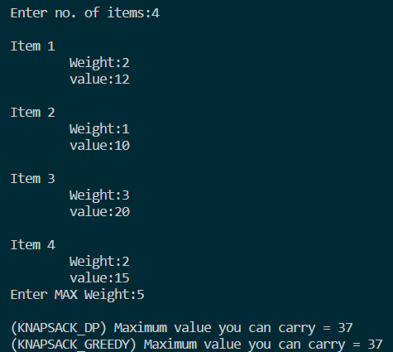

1. To Implement Prim’s Algorithm for MST
   1. **Code:**

#include <stdio.h>

#include <stdlib.h>

#include <string.h>

#include <bits/stdc++.h>

using **namespace** std;

typedef **struct** Graph *graph;

typedef **struct** Graph

{

**int** nv;

**int** **am;

*// Array to store constructed MST*

**int** *parent;

*// Key values used to pick minimum weight edge in cut*

**int** *key;

*// To represent set of vertices included in MST*

**bool** *MST_Set;

} Graph;

graph creategraph(**int** v)

{

    graph g = (graph)malloc(sizeof(Graph));

    g->nv = v;

    g->am = (**int** **)malloc(v * sizeof(**int** *));

    g->parent = (**int** *)malloc(v * sizeof(**int** *));

    g->key = (**int** *)malloc(v * sizeof(**int** *));

    g->MST_Set = (**bool** *)malloc(v * sizeof(**bool** *));

    for (**int** i = 0; i < v; i++)

    {

        g->am[i] = (**int** *)malloc(v * sizeof(**int**));

    }

*// initialising graph*

    for (**int** i = 0; i < v; i++)

    {

        for (**int** j = 0; j < v; j++)

        {

            g->am[i][j] = 0;

        }

    }

*// Initialize all keys as INFINITE*

    for (**int** i = 0; i < v; i++)

    {

        g->key[i] = INT_MAX;

        g->MST_Set[i] = false;

    }

    g->key[0] = 0;

    g->parent[0] = -1;

    return g;

}

graph fillmatrix(graph g, **int** i, **int** j, **int** w)

{

    if (i < g->nv && j < g->nv)

    {

        g->am[i][j] = w;

        g->am[j][i] = w;

    }

    return g;

}

graph getgraph(graph g)

{

**char** v1, v2;

**int** width;

    printf("\nEdge:\n\tvertice 1:");

    scanf(" %c", &v1);

    printf("\tvertice 2:");

    scanf(" %c", &v2);

    printf("\tweight:");

    scanf("%d", &width);

    while (v1 != '0' && v2 != '0')

    {

**int** vv1 = v1 - 'A';

**int** vv2 = v2 - 'A';

        g = fillmatrix(g, vv1, vv2, width);

        printf("\nEdge:\n\tvertice 1:");

        scanf(" %c", &v1);

        printf("\tvertice 2:");

        scanf(" %c", &v2);

        printf("\tWidth:");

        scanf("%d", &width);

    }

    return g;

}

**void** printadjmat(graph g)

{

    printf("\n=====Adjacancy Matrix=====\n");

    printf("\t");

    for (**int** i = 0; i < g->nv; i++)

    {

        printf("%c\t", 'A' + i);

    }

    printf("\n");

    for (**int** i = 0; i < g->nv; i++)

    {

        printf("%c\t", 'A' + i);

        for (**int** j = 0; j < g->nv; j++)

        {

            printf("%d\t", g->am[i][j]);

        }

        printf("\n");

    }

}

*// function to pick minimum key from vertex*

**int** minkey(graph g)

{

**int** min_val = INT_MAX;

**int** min_index;

    for (**int** i = 0; i < g->nv; i++)

    {

        if (g->MST_Set[i] == false and g->key[i] < min_val)

        {

            min_val = g->key[i];

            min_index = i;

        }

    }

    return min_index;

}

**void** printMST(graph g)

{

    cout << "\n\n Edge\tWeight\n";

    for (**int** i = 1; i < g->nv; i++)

    {

        cout << (**char**)(g->parent[i] + 'A') << " - " << (**char**)(i + 'A') << "\t" << g->am[i][g->parent[i]] << endl;

    }

}

**void** primsMST(graph g)

{

    for (**int** i = 0; i < g->nv - 1; i++)

    {

*// picking minimum key from vertex and not included in MST*

**int** min_key = minkey(g);

*// set the min_key as added to MST*

        g->MST_Set[min_key] = true;

*// Updating the key value and parent index of the adjacent vertices of the selected vertex*

        for (**int** j = 0; j < g->nv; j++)

        {

            if ((g->am[min_key][j]) and (g->MST_Set[j] == false) and (g->am[min_key][j] < g->key[j]))

            {

                g->parent[j] = min_key;

                g->key[j] = g->am[min_key][j];

            }

        }

    }

    printMST(g);

}

**int** main(**int** argc, **char** **const** **\***argv[])

{

**int** n;

    printf("\nEnter no. of vertices:");

    scanf("%d", &n);

    graph g;

    g = (graph)malloc(sizeof(Graph));

    g = NULL;

    g = creategraph(n);

    printf("\nEnter Edges(Enter '0 0 0' to exit):\n");

    g = getgraph(g);

    printadjmat(g);

    primsMST(g);

}

* 1. **Output:**

Graph Used:

1. 

